**Curry Goat**

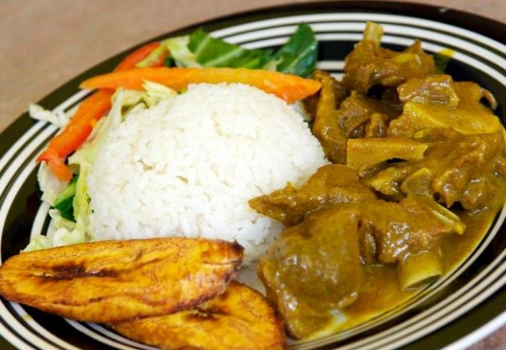

**INGREDIENTS**

2 1/2lbs Goat Meat

1 Medium Carrot

1/2Tsp Salt

1/2Tsp Dried Thyme

4 Pimento Berries

1Tsp All Purpose

1 Large Onion

1/2Tsp Black Pepper

1 Green Scotch Bonnet Pepper

2 Stalk Escallion

1 Clove Garlic

3Tbsp Vegetable Oil

3Tbsp Indian Curry

1 Medium Iris Potato

**METHOD**

1. Wash and Cut up Seasonings, Irish, Carrot.
2. Cut Goat Meat into bite sizes then rinse 2 times with water drain and leave into the bowl.
3. Add salt, all-purpose, dried thyme, black pepper, Indian curry, and massage into the goat meat cover and allow to rest for at least 30 minutes it can be more.
4. After the 30minutes place pressure cooker on the stove add oil and turn the heat on high and allow the pot to be heated. When the pot is heated add the pieces of the goat meat and cook evenly on all sides. Stir as needed.
5. After all the pieces have been seared. Catch water in the bowl that the goat meat was marinating in for any residue of seasonings and pour into the pressure cooker just enough to cover the meat. Cover the pot and allow to pressure for 35minutes on medium heat.
6. After pressuring for 35 minutes turn off the stove and remove pressure cooker from the stove and allow all the pressure to release.
7. After the pressure has been released, Pour contents from the pot into a big enough pot and add Pimento berries, Escallion, Onion, Irish, Carrots, Scotch bonnet pepper, and 1/2Tsp Salt. Stir to mix evenly and cover for an additional 20-25minutes on medium heat.
8. Stir as needed. Let it cook until the excess water has reduced and the carrots and Irish are cooked through and gravy has thickened and reached to your liking. Once done turn the heat off and serve.